1. **GEN AI Project Anomaly Detection Milestone:**

* Load the dataset into ADLS Gen2, or establish lineage from another data source such as SQL Server.
* Move files from one location to another.
* Use Databricks for Unity Catalog, distributed processing, MLflow, and other prerequisite libraries.
* Write PySpark code for data preprocessing, and work with existing models such as GPT-4 or other LLMs, including fine-tuning.
* Regardless of model accuracy, leverage Azure AI Foundry for AI Hub, along with its keys and endpoints.
* Use Azure ML Studio for model deployment and endpoint serving.
* For continuous integration and deployment (CI/CD), Azure DevOps is an essential tool.
* Finally, send notifications—via email or other messaging systems—to end users, such as higher authorities or LOBs.

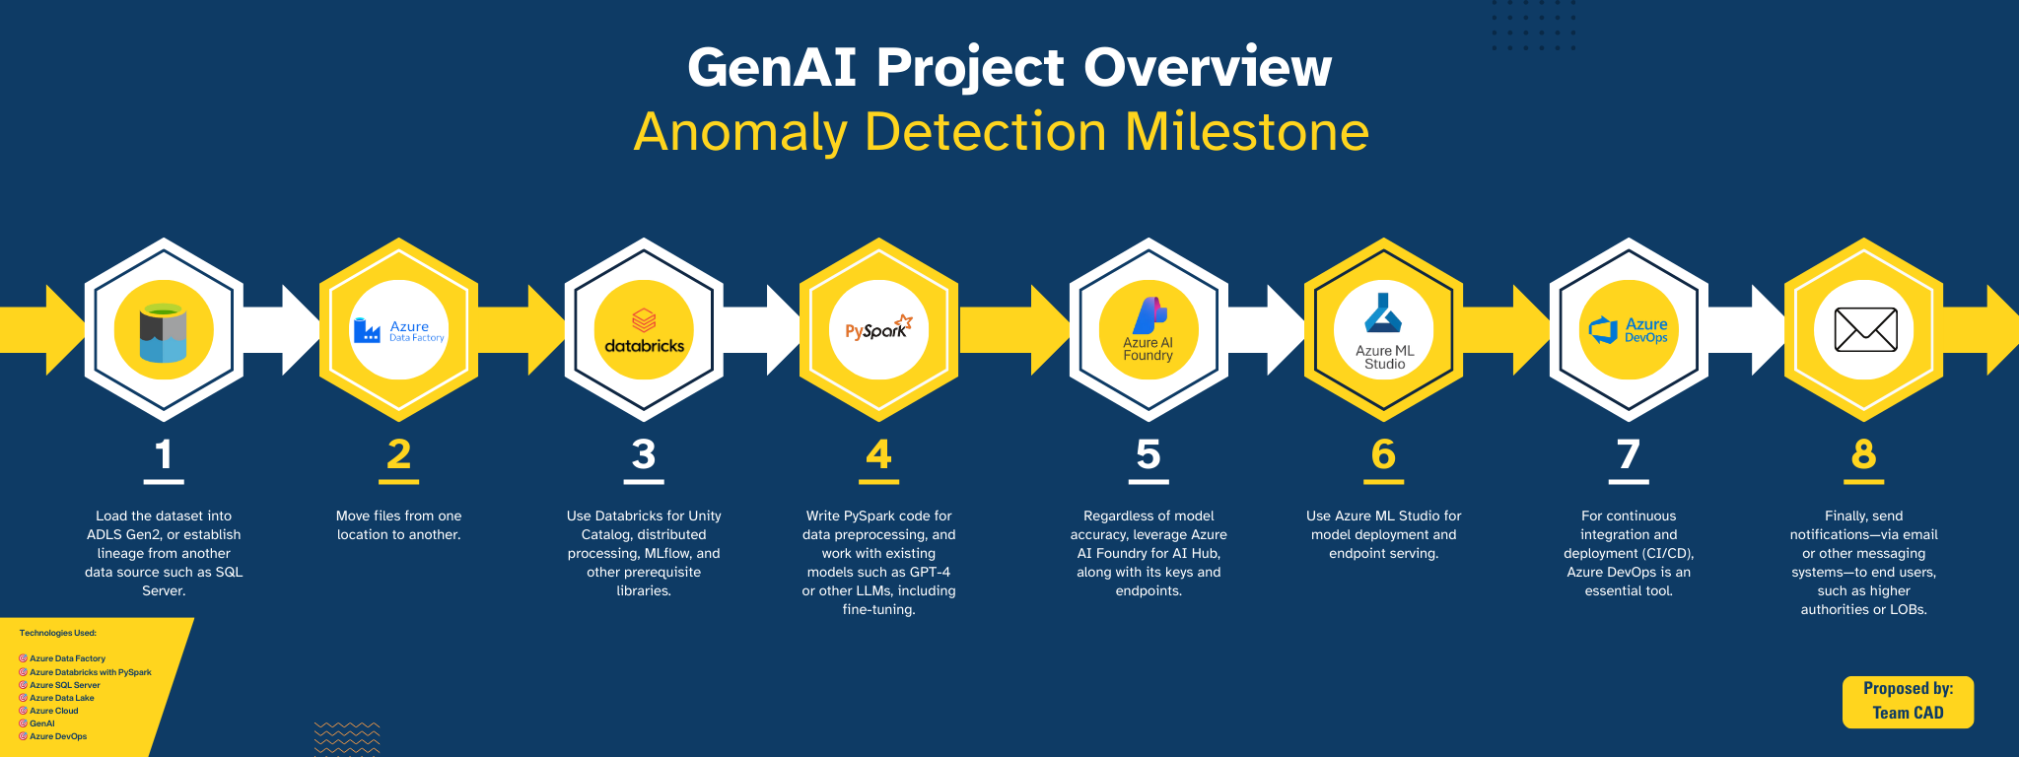

**Resource:**

1. <https://www.zendesk.com/in/blog/nps-net-promoter-score/>
2. <https://cloud.getwren.ai/projects/8788/home>